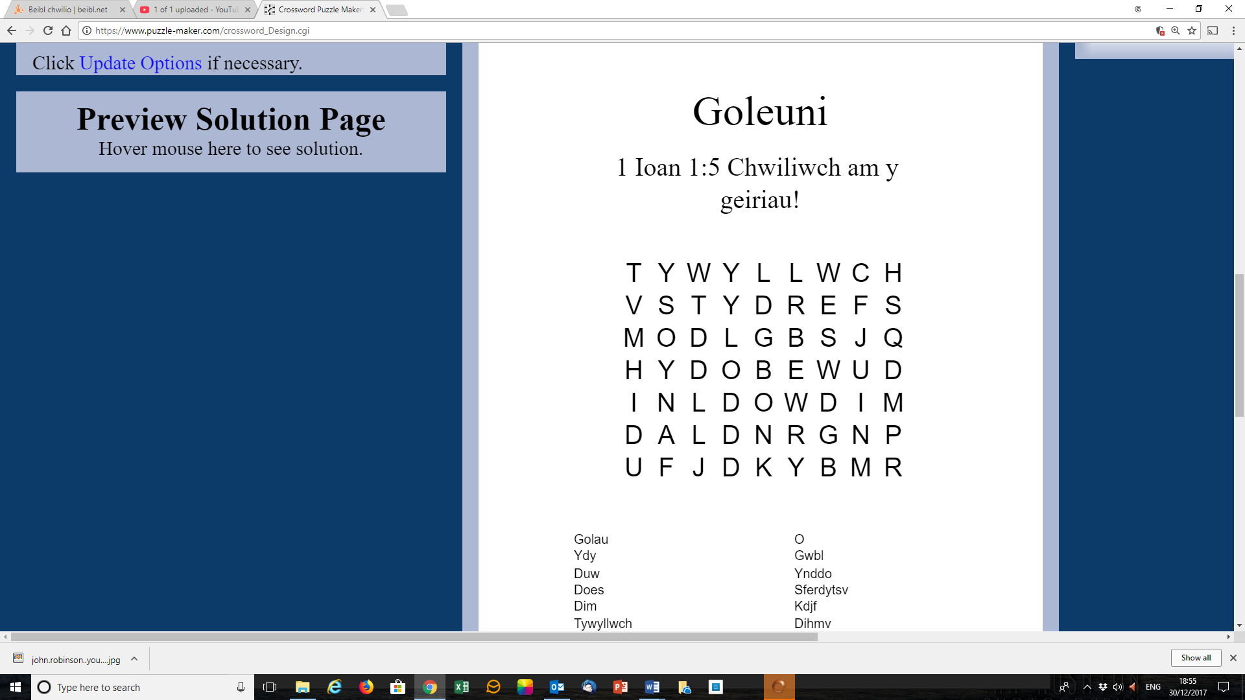

Golau ydy Duw; does dim tywyllwch o gwbl ynddo.

(1 Ioan 1:5)